Chapter – 3
Purplle Online Beauty Shopping Management System
Introduction
In this stage of the Purplle Online Beauty Shopping Management System project, the Entity-Relationship (ER) diagrams are created to visually represent the structure of the database. Each entity is identified with its attributes and primary keys, while the relationships between entities are defined based on the business requirements of the online beauty shopping platform.
The ER diagrams illustrate how customers, products, categories, suppliers, inventory, orders, order details, payments, and administrators interact within the system. Appropriate cardinality and relationship constraints are used to clearly represent the connections among these entities. This conceptual database design serves as the foundation for creating the relational database schema and implementing an efficient, secure, and well-organized e-commerce database.

Entity Relationship (ER) Diagram and Relationships
The following ER diagrams represent the entities involved in the Purplle Online Beauty Shopping Management System. Each entity contains its attributes, primary keys, and relationships with other entities. These diagrams provide a clear understanding of the database structure and help in designing an efficient relational database for the online beauty shopping platform.

1. Customer
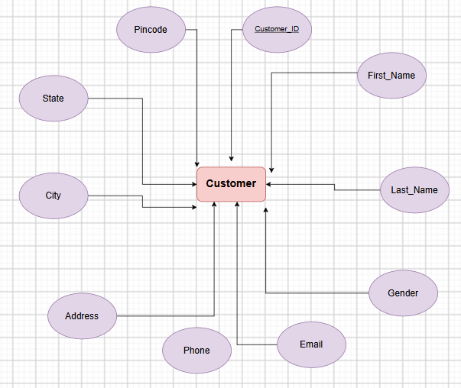
2. Category
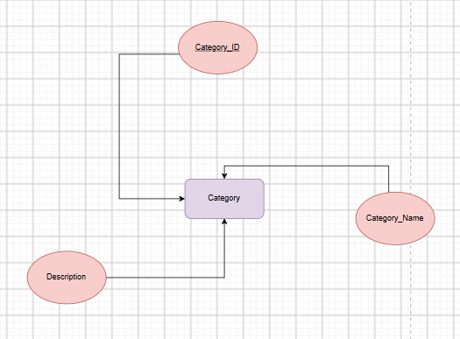

3. Brand
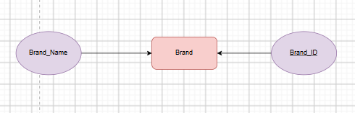

4. Seller
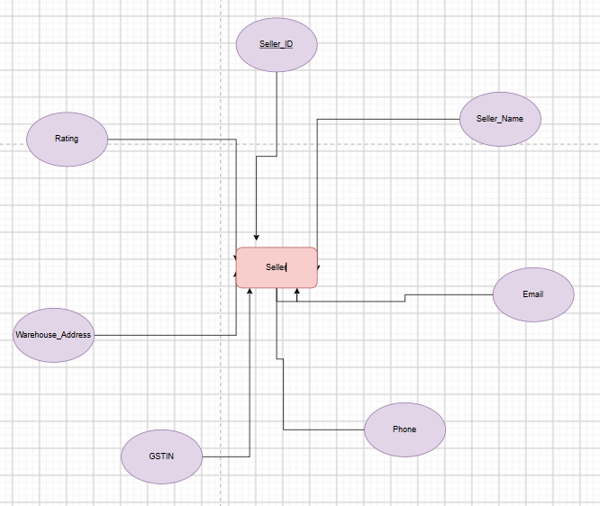
5. Product
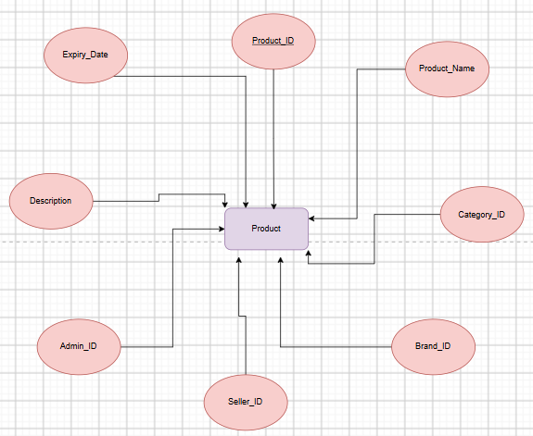

6. Product_Variant
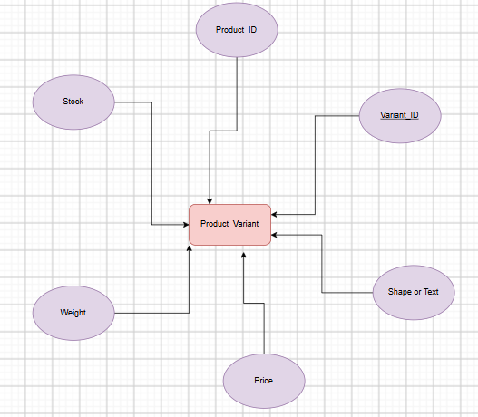

7. Cart
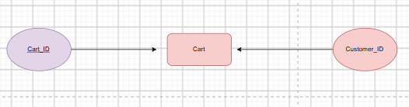

8. Cart_Item
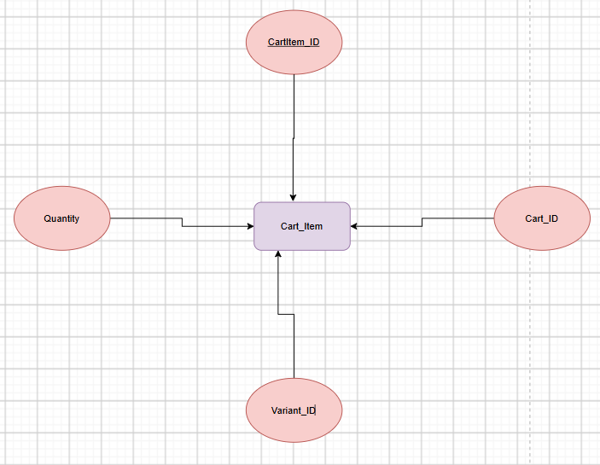

9. Wishlist
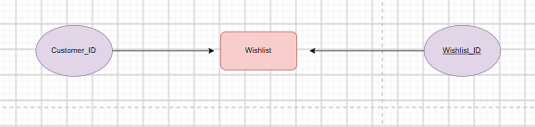

10. Wishlist_Item
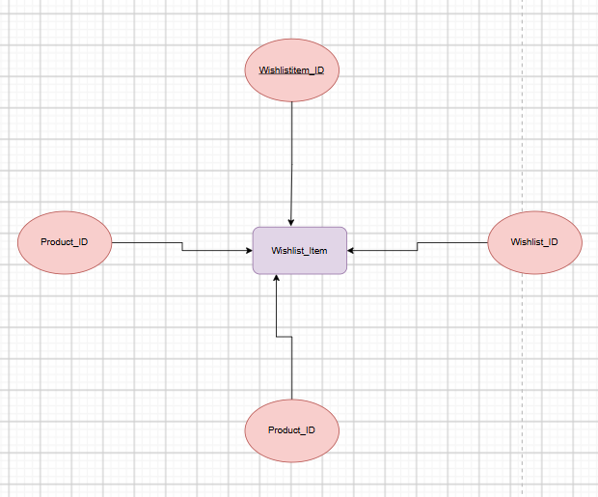

11. Coupon
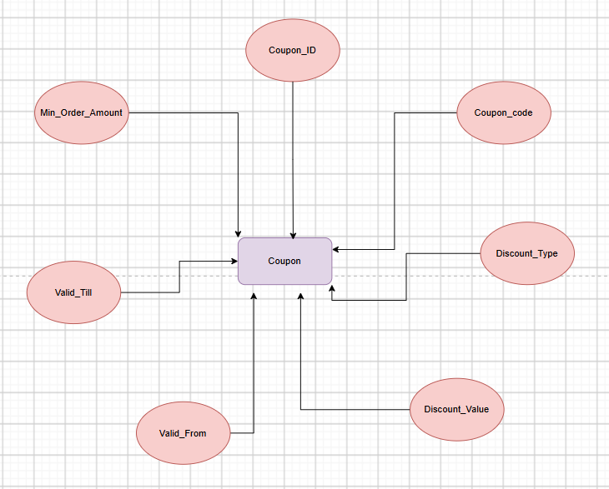

12. Orders

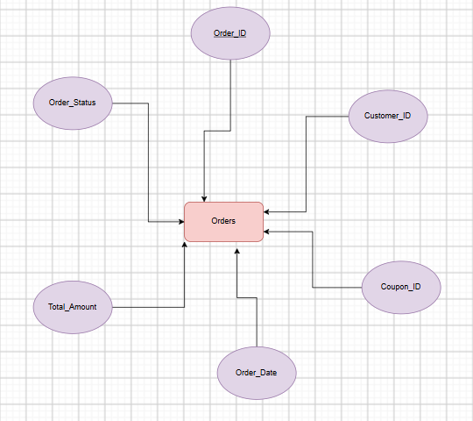

13. Order_Details
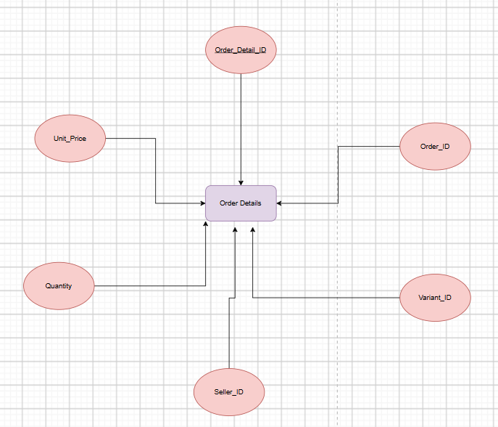
14. Payment
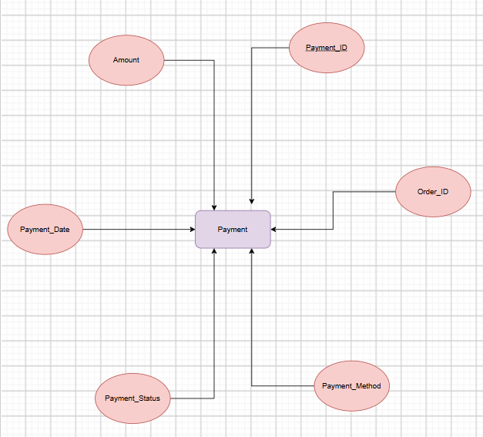

15. Delivery
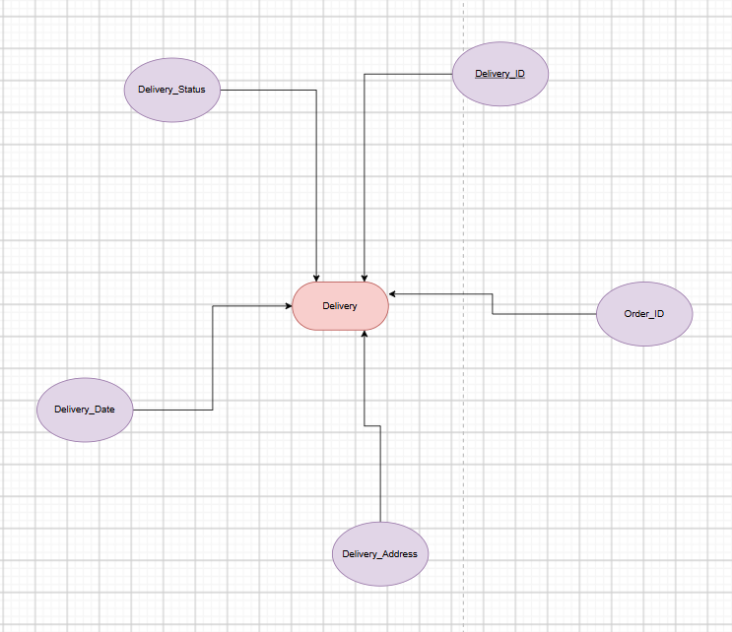
16. Review
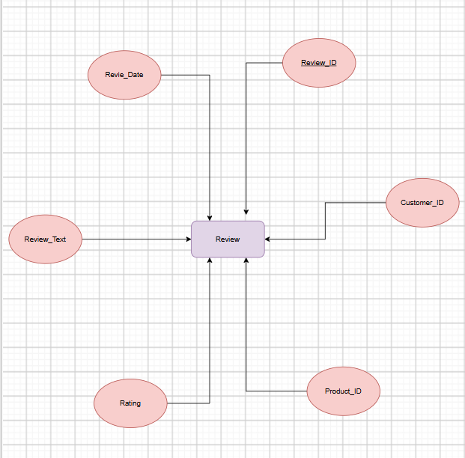

17. Admin
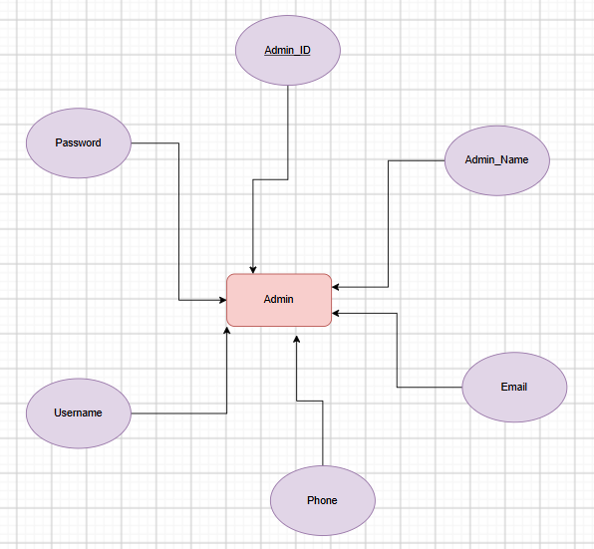

18. Relationships

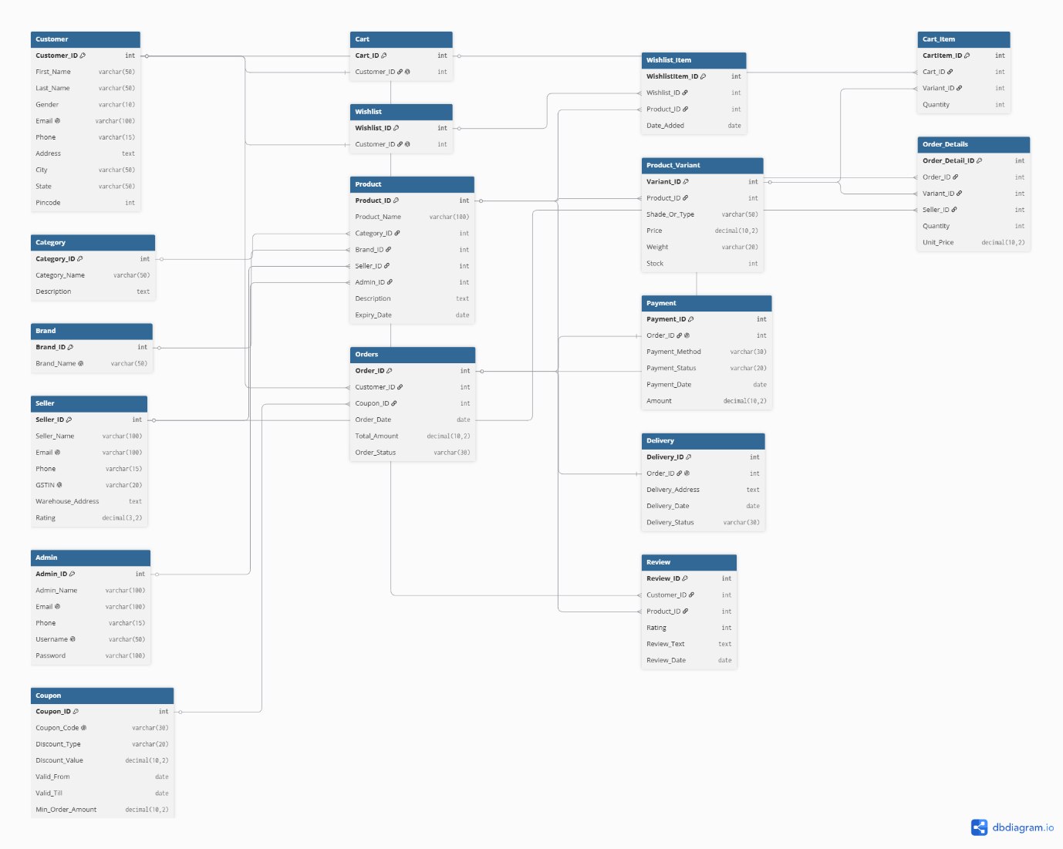

Overall ER Diagram
